**Pearson Chapter 9.4 – Expansion of the Universe**

Parsec: The distance you have to be from the Earth so that the radius of the Earth’s orbit around the Sun would make an angle of one second of arc.

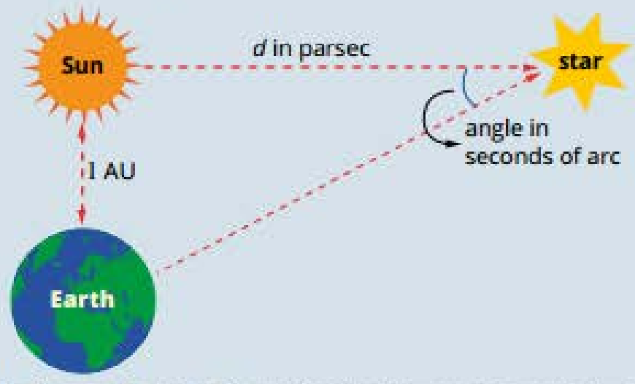

Although the absorption spectra of the stars contained the familiar sets of lines that revealed the presence of various elements, all the lines seemed to be shifted towards the red end of the spectrum – redshift.

The more distant the galaxy, the greater the redshift.

The recessional velocity is proportional to the distance from the Earth (Hubble’s Law).

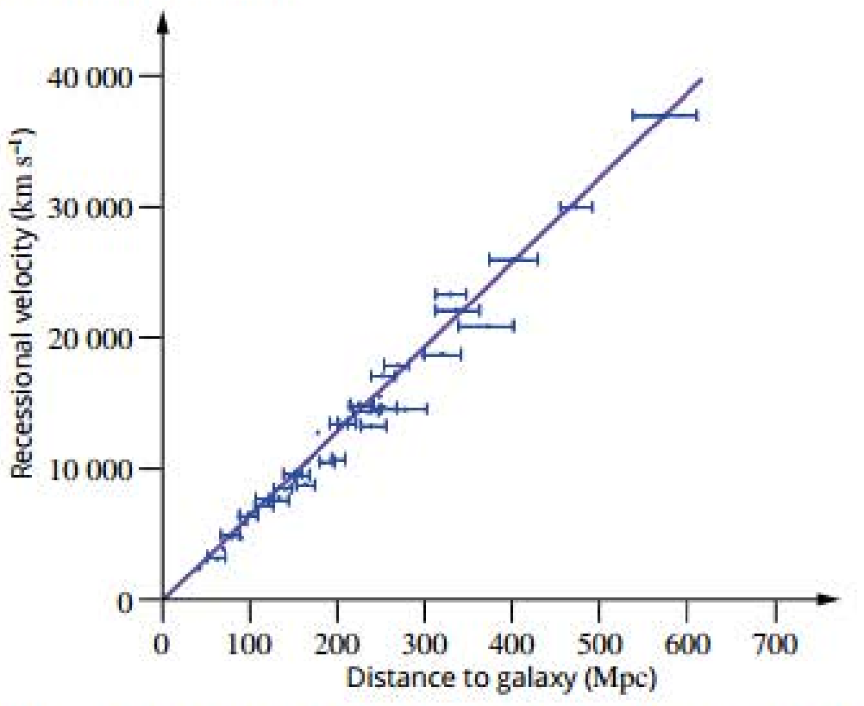

H0 ≈ 70 km s-1 Mpc-1

Hubble explains expansion of the universe:

* Because all the distant galaxies were receding from us, space itself was expanding rather than the galaxies rushing away from us.
* At a very large distance from the Earth, space will be expanding faster than the speed of light and thus the light from stars would never reach us.
* This isn’t the “edge of the universe” – it’s a distance beyond which humans will never see (the “edge of the visible universe”).
* Nothing is travelling through space faster than speed of light (doesn’t violate Einstein’s special relativity).

Interpreting Hubble’s law:

* It can’t be explained by saying all stars are exploding outwards from us as we’d expect all distant galaxies to be moving away at the same speed.
* It can’t be explained by saying all stars are exploding out from a point distant from us as we wouldn’t expect a linear relationship in all directions.
* It can be explained by saying that space itself is expanding. All galaxies are effectively moving away from each other, and the further they are, the faster they’re moving apart, causing the points to become further apart without moving through space themselves.

Modelling the expanding universe:

* Imagine an ant on an expanding balloon. The dots represent the stars.
* As the balloon expands, the ant would see all the dots moving away from it.
* Wherever the ant wanders, the dot would still be expanding away from it.
* The dots remain the same size rather than expanding. It’s space that’s expanding, not the stars and galaxies in it.
* Unlike a conventional explosion, as space expands, it will appear uniform in whatever direction you look and from wherever you look. There’s no “centre” of the universe.
* The dots are stuck on instead of drawn on as if they were drawn on, the dots would expand whereas the stuck-on stars remain the same size.

Cosmological redshift:

* Although the redshift seen in distant galaxies was originally thought to be a Doppler shift from recessional motion, it’s more correctly interpreted as the direct consequence of expanding space.
* The wavelength of the radiation increased with space rather than in space.
* This type of redshift is more correctly called “cosmological redshift”.

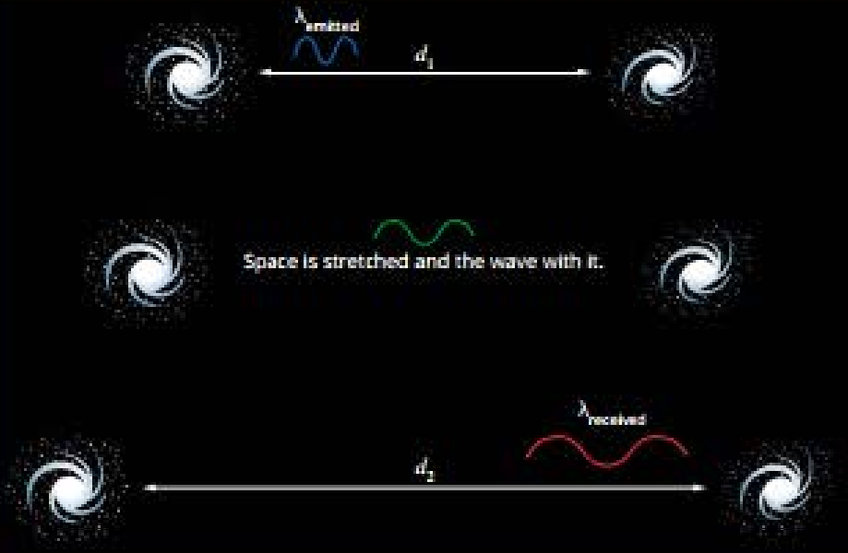

Steady State theory:

* The universe is infinite – the outer stars would never reach infinity and so could go on moving away from us forever.
* The universe is expanding – matter is being created all the time at just the right rate to keep the density of the universe constant.

Big Bang theory:

* Galaxies outside the Milky Way were moving away from us, implying that there was an instant in time where the universe and everything in it was contained in a single point.
* Everything was created from nothing in a “big bang”.
* All the matter and energy present in our universe was packed together in some infinitely small region which rapidly expanded.
* The theory predicts that energy was converted into matter in the early universe. The universe rapidly expanded and cooled. Millions of years later, this matter began to condense into galaxies as the universe continued to expand.

Steady State vs Big Bang theory:

* If the Steady State theory is true, where should scientists look for the new matter being created?
* If the Big Bang Theory is true, how could they know?
* Observational evidence (an expanding universe) was consistent with both theories.

|  |  |
| --- | --- |
| Big Bang theory | Steady State theory |
| Expanding universe: Space is expanding between galaxies. | |
| Isotropic universe: The universe has no preferred orientation – it looks the same viewed from all directions. | |
| Homogenous universe: There’s an even distribution of matter throughout the universe at the large scale – it looks the same in all places. | |
| Universal law of physics: Physical constants and laws are the same throughout the universe. | |
| Space, time, matter and maybe even the laws of physics come into existence at a specific point in time.  All matter came into being very early after the Big Bang.  The density of matter in the universe is decreasing as space expands, allowing for an end of the universe. | Eternal universe: There’s no beginning or end – it looks the same at all times.  New matter is created constantly between galaxies to maintain density of matter in the universe. |

The Big Bang isn’t some sort of explosion from a small point in space. It was more an explosion of space. In fact, it was more correctly an explosion of spacetime. The Big Bang wouldn’t have occurred at some point in time any more than it would have occurred at a point in space. Time, space and matter were all created together in the one “big bang”.

Cosmic microwave background radiation:

* In the Big Bang, the temperature near the beginning would’ve had to have been hot enough to create a lot of helium from the fusion of hydrogen nuclei.
* Any hot object gives off blackbody radiation. This would’ve been intense, high-energy gamma radiation that would’ve filled all space in the early universe and would’ve been radiating out ever since.
* If the radiation was still present, it’d have become very low-energy, long-wavelength radiation. Energy wasn’t lost – as space expanded, so would the wavelength of the radiation.
* Unlike galaxies, which are held together by their gravity, the radiation would’ve expanded with space and so the wavelength would have increased greatly.
* The Steady State theory had no explanation for this radiation.
* This cosmic microwave background radiation is uniform from all directions and corresponds to the radiation expected from a blackbody at a temperature of 2.725K.

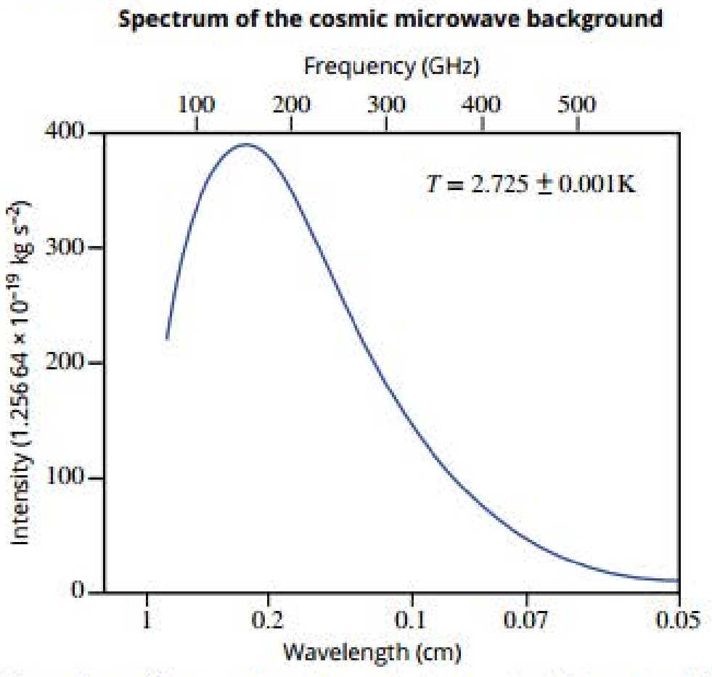

Further evidence for the Big Bang:

* How could galaxies and stars form in this totally homogenous universe? Was the early universe really so bland?
* There are very small variations in the temperature of the microwave background.
* For stars and galaxies to form, there had to be some variation in the structure of the early universe so that local clumps of matter could start to coalesce and form galaxies.
* Once a clump of matter starts to form, its gravity will accelerate the process.
* As the matter falls inwards, the temperature rises, creating the conditions for the formation of stars.
* This early variation would’ve resulted in slight variations in the gamma radiation produced and in the cooled-down form that we see as cosmic microwave background radiation.

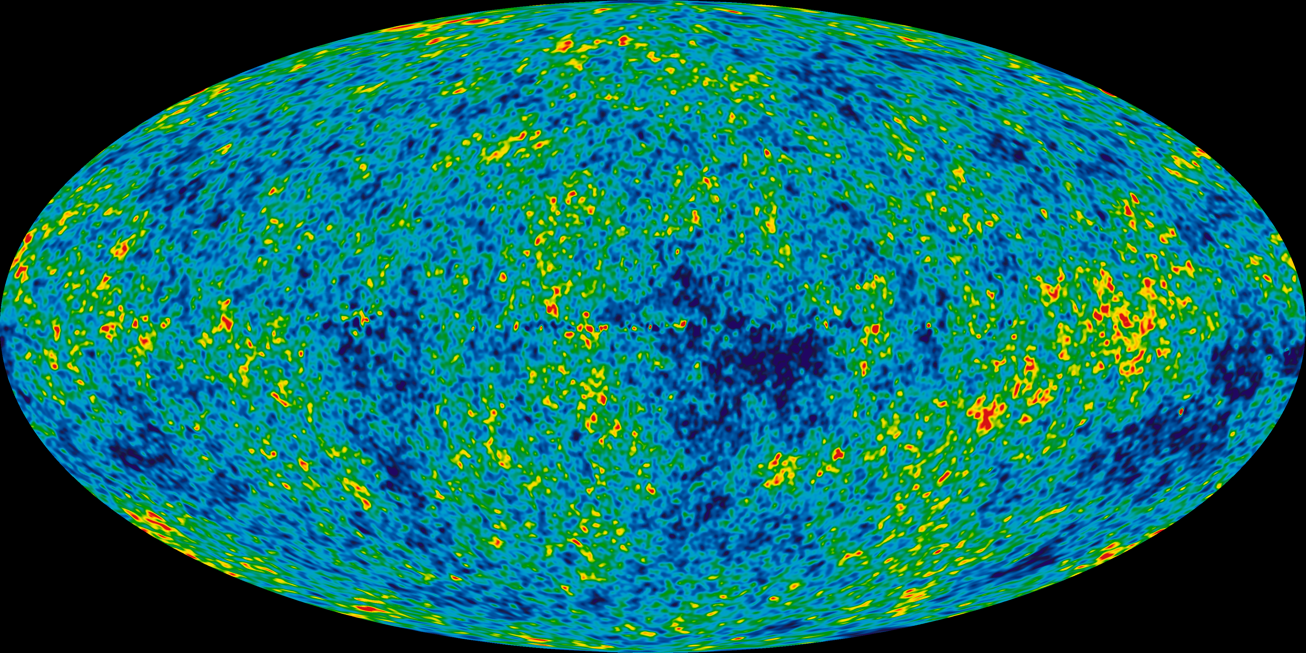

Evidence for the Big Bang:

|  |  |
| --- | --- |
| Expansion of space | The degree of redshift increases with distance → space is expanding. |
| Observations of galaxy formation and evolution and the distribution of large-scale cosmic structures. | Detailed observations of the shape and distribution of galaxies and quasars agree with predictions of the Big Bang theory.  Galaxies of different ages appear notably different (unable to be explained by the Steady State theory). |
| Cosmic microwave background radiation | The early universe should’ve been filled with high-energy radiation matching a high temperature blackbody spectrum.  The radiation should still be present in the universe but with its wavelength increased due to the expansion of space, so it should now match a lower temperature blackbody spectrum/ |
| Relative abundances of light nuclei | In the early universe, protons and neutrons were formed and were then able to undergo reactions to form hydrogen, helium and lithium.  This would’ve occurred whilst the universe was hot and dense enough for fusion reactions to occur at a significant rate.  This leads to very specific predictions about the ratios of the abundance of these isotopes in the universe which agree with experimental values. |

Age of the universe:

$$v=\frac{s}{t}=H_{0}d$$

$$\frac{1}{t}=H_{0}$$

$$t=\frac{1}{H_{0}}$$

$$t≈\frac{1}{70}km s^{-1} {Mpc}^{-1}$$

Converting to years:

$$1Mpc=3.09*{10}^{19}km$$

$$H_{0}≈70km s^{-1}{Mpc}^{-1}$$

$$=\frac{70}{3.09*{10}^{19}}s^{-1}$$

$$=2.27*{10}^{-18}s^{-1}$$

$$=4.41*{10}^{17}s$$

$$=1.40*{10}^{10}years$$

$$=14 billion years$$

This method of determining the age of the universe has assumed a constant rate of expansion and ignored the effects of gravity. Neither of these are totally valid assumptions, but these effects tend to cancel each other out and more complex models still produce an age close to 14 billion years.

Inflation:

* In the initial stages of the Big Bang, there must have been a period of inflation.
* Inflation prevented a very rapid collapse of the initial universe back into a black hole.
* If it had lasted any longer, the expansion would’ve been so great that particles would’ve never.

Matter and antimatter:

* Heisenberg uncertainty principle: In any very short time, there’s a fundamental uncertainty about mass. The shorter the time, the greater the uncertainty. In a very short time, mass can come into and out of existence from nothing.
* When particles are created, they always come in pairs.
* For every “matter” particle, there’s an “antimatter” particle.
* Because they’re close when they come into existence, the matter and antimatter immediately annihilate.
* Matter (and antimatter) are constantly popping into and out of existence everywhere. We just can’t see it because it doesn’t last.

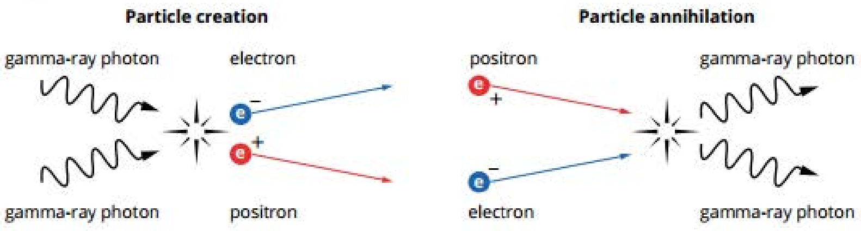

Creation of lasting matter:

* In the period of inflation, because of the extremely rapid expansion of space, the pairs of particles are rapidly separated and don’t get a chance to annihilate, and so, in the tiny fraction of a second of inflation, huge amounts of matter were created.
* In those first moments after inflation, the universe was chaotic with particles and antiparticles annihilating each other rand producing high-energy gamma photons.
* Those photons themselves again collided with others and their energy formed new particles.
* After 0.0001s, the temperature of the expanding universe was too low for the creation of new particles but there was wholesale annihilation of matter with antimatter and a huge reduction in the total amount of matter.
* The annihilation also produced an enormous amount of radiation.
* This radiation filled all space and dominated the universe (cosmic microwave background radiation).
* In the first few seconds, quarks combined to form protons and neutrons, then protons and neutrons were formed close enough to fuse together, forming hydrogen, helium and lithium nuclei.
* Later, the temperature dropped below that needed for fusion and no further nuclei were formed.

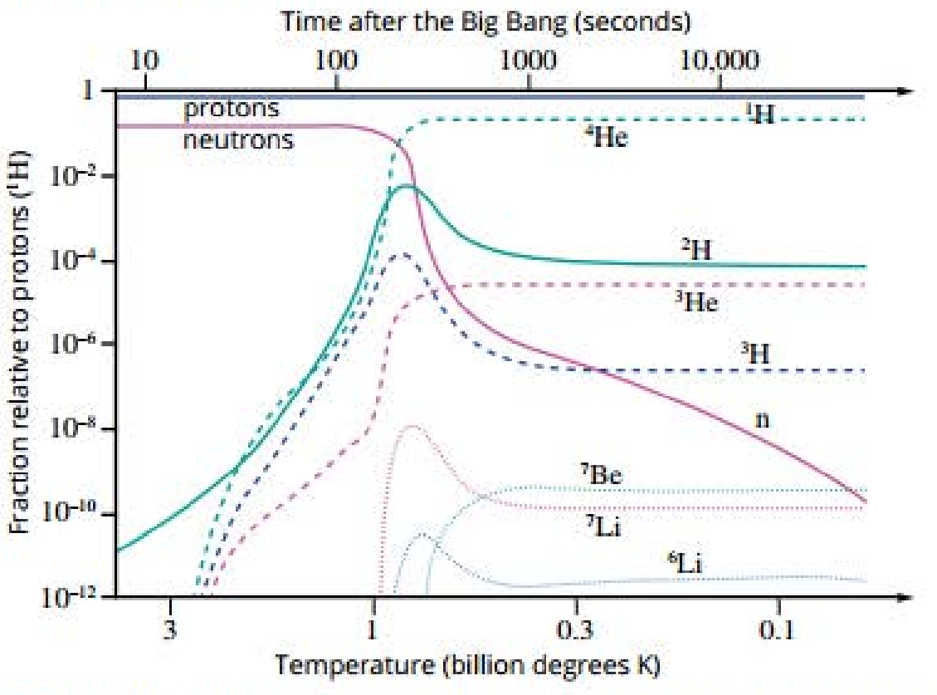

* There wasn’t an even balance of matter and antimatter in the early universe, and so after the initial rapid annihilation, there was actually matter left over.
* The imbalance between matter and antimatter means the leftover matter made our universe.
* An observer would’ve found it immensely bright and very opaque because of the interactions of the high-temperature photons with all the various particles.
* Later, the expansion resulted in cooling to the point where the photon energy dropped into the infrared region of the spectrum. The photons no longer interacted with the nuclei and so the universe became completely dark.
* For this reason, it became possible for hydrogen and helium nuclei to hold onto electrons and form the first neutral atoms.
* The photons left over no longer interacted with anything and so have gone on flying through the universe – cosmic microwave background radiation.

From the Big Bang to the evolution of life:

* It took the supernova explosions of the early stars to produce the rest of the elements of the periodic table, elements from which life would finally start to evolve.

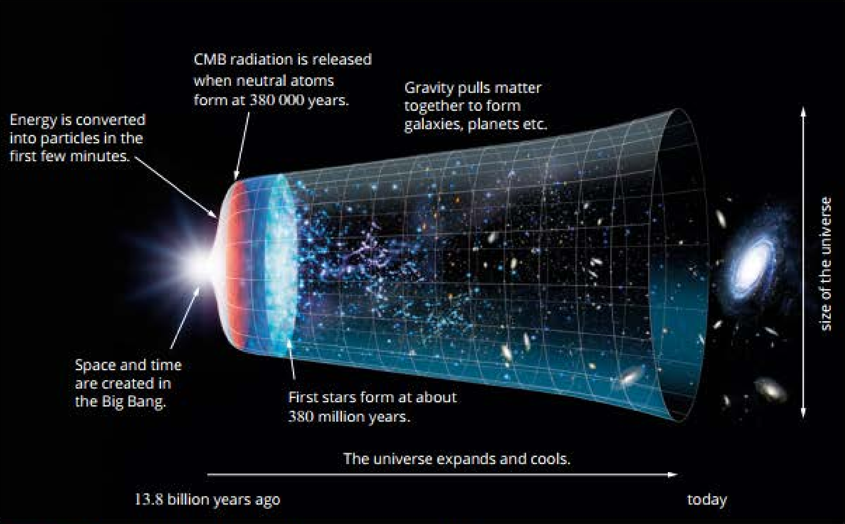

Possible futures of the universe:

* Space is expanding but gravity could stop it.
* Big Crunch: The density of matter in the universe is high enough so that space has a positive curvature, allowing gravity to slow down and reverse the expansion of the universe.
* Big Freeze: If the density is too low, space has a negative curvature, meaning gravity will slow down the expansion but never stop it.
* Big Freeze: If the density of matter is the critical density, space will ave zero curvature – space will expand for an infinite amount of time.

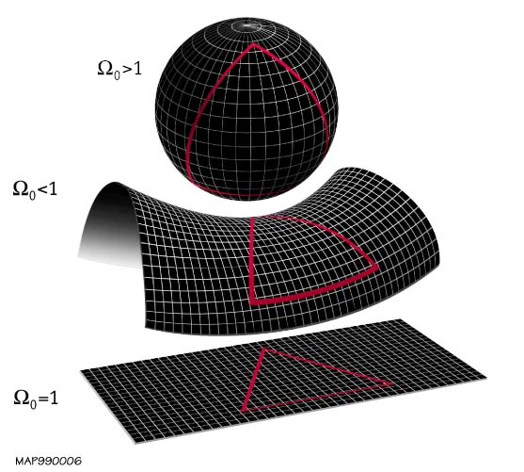

The expansion seems to be accelerating. This is thought to be caused by dark energy. Dark energy remains mysterious but can be thought of s fundamental energy of space that exerts a negative gravitation. As the universe expands, the density of matter decreases but the density of dark energy would remain more or less the same, accelerating expansion.

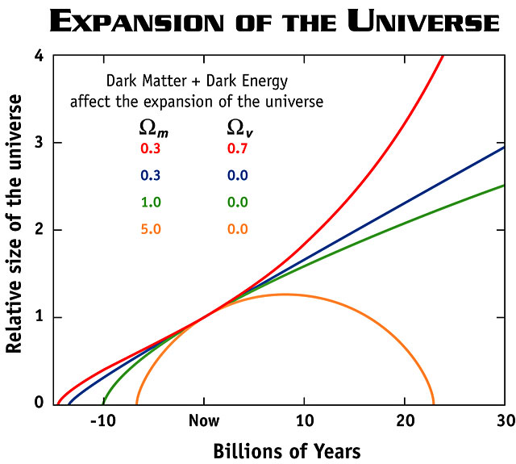

Big freeze:

* Space between the cluster of galaxies will grow at an increasing rate.
* Supplies of gases need to form so stars will deplete.
* Existing stars will run out of fuel and cease to shine.
* Universe will grow darker.
* If protons are unstable then stellar remnants will disappear.
* Eventually, even black holes will evaporate through Hawking radiation.
* The universe will approach a uniform temperature so no work will be possible.

Revision

Q: All distant stars are seen to be receding from the Earth. Does this mean we’re at the centre of the universe? Explain.

No. If we were the centre of the universe, we’d expect all distant stars to be receding at the same velocity. Instead, we observe a linear relationship between distance and recessional velocity which c’n't be explained by us being at the centre of a conventional explosion.

Q: Does the universe have a centre? Explain.

No. Data suggests that the universe is most likely infinite and so doesn’t have a centre.

Q: Briefly explain the evidence that supports the Big Bang theory.

The linear relationship between distance to a star and its recessional velocity is best explained by the expansion of space, suggesting that back in time, space expanded out from a singularity.

The Big Bang theory predicts that the universe should be filled by radiation emitted soon after the Big Bang that has been stretched to microwave radiation. This cosmic microwave background radiation was later discovered with a spectrum that agreed to this prediction.

The relative abundances of light isotopes line up well with predictions made by the Big Bang theory.

There’s slight variations in the amount of radiation throughout the universe, which would allow for local clumps of matter to coalesce and form stars and galaxies, supporting the Big Bang theory.

Q: Contrast the Big bang theory with the Steady State theory.

The Big Bang theory describes a universe that changes over time with the average density of matter over the universe decreasing as space expands. The Steady State theory describes a universe that essentially doesn’t change over time, with new matter coming into existence to maintain a constant average density of matter over the universe as space expands.

Convert from pc to km: Multiply by 3.09 x 1013.